**D3 - Demonstrate that a created website meets the defined requirements and achieves the defined purpose**

**Introduction**

In this report, I will be explaining how I have met the requirements that were set. I will be explaining each of the requirements with screenshots evident.

**Home Page**

This is the main page and every page is similar to this page.

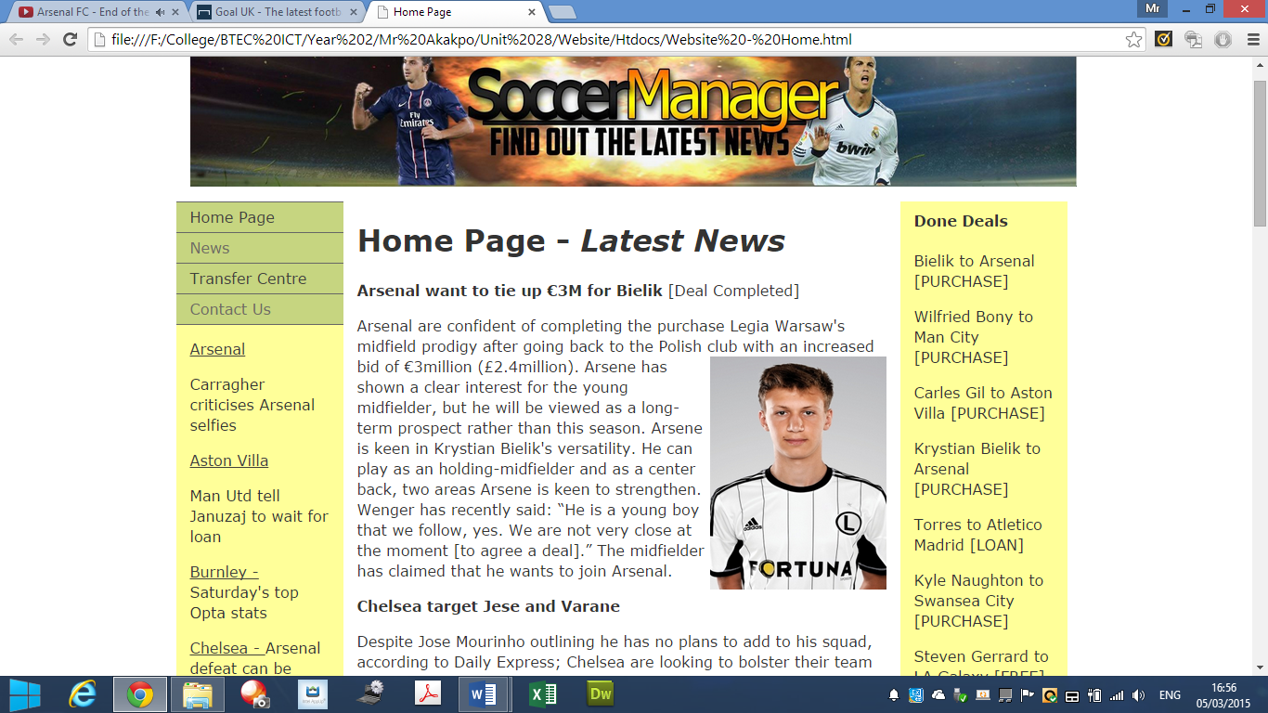

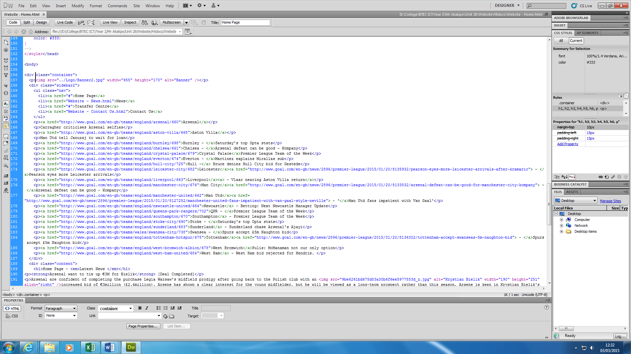**HTML Coding**

This is the backbone of the page. There is more, but this is only part of it. This is where I went to refer to if there is any problem. For example, if I were to insert a video on my page, I will need the embedded code. Once I have the code, I will insert it on the screenshot above.

**My Website**

On each page, it consists of the same template with the banner too. I have four main pages on each, which are home; news; transfer centre and contact us. Videos and Galleria are pages too, but that can be accessed on home page where it says ‘click here’. The only difference is the colour. My website meets the requirements, because it has a series of features that have been included within my website. The brief said it must consist of interactivity. Here it is.

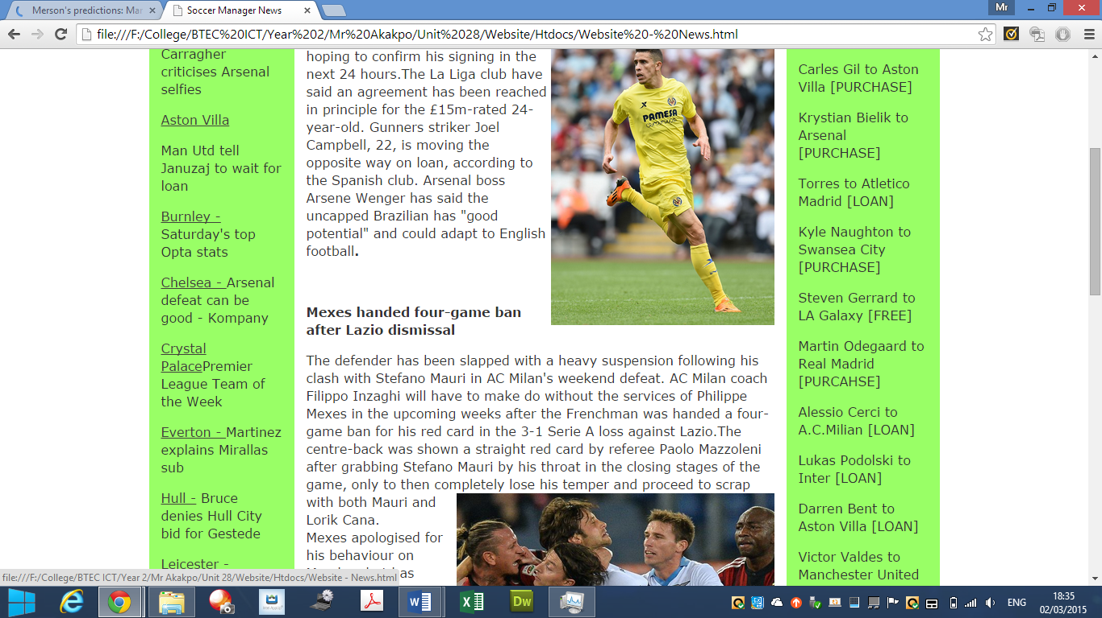

**Images**

Images is the main feature on any website. It shows the user a different way for the user to interpret the information. I have used many of these images on my website. This image shows that I have used more than one.

**Animation**

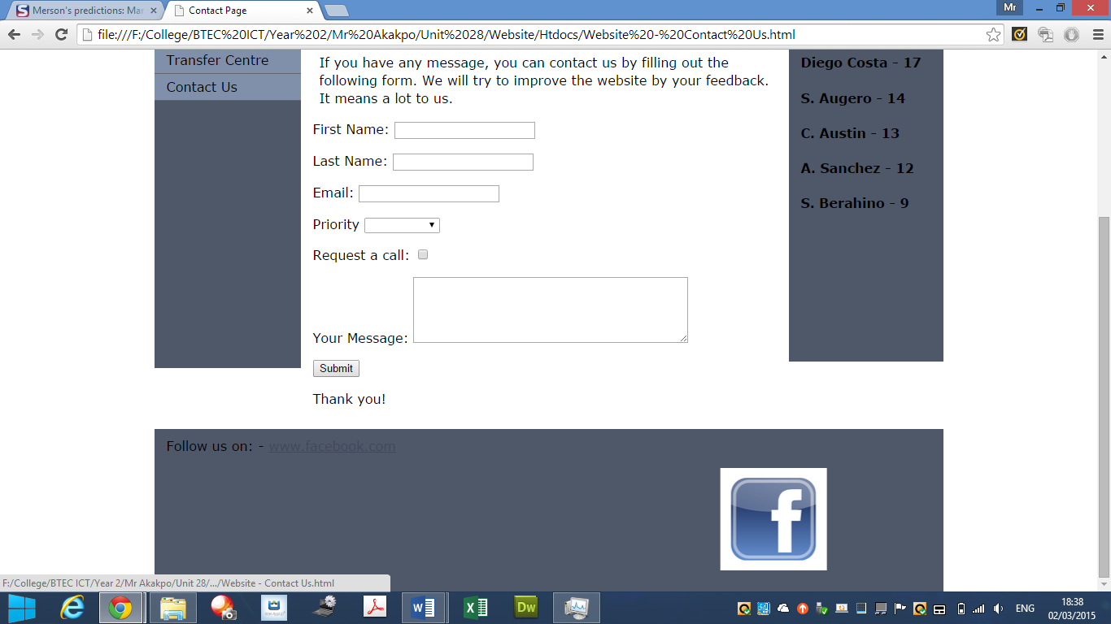Animations can be used in many ways. I have used it for the user to keep in touch with our website by using it right at the bottom. This is the most effective way to grab attention. It goes back and forth.

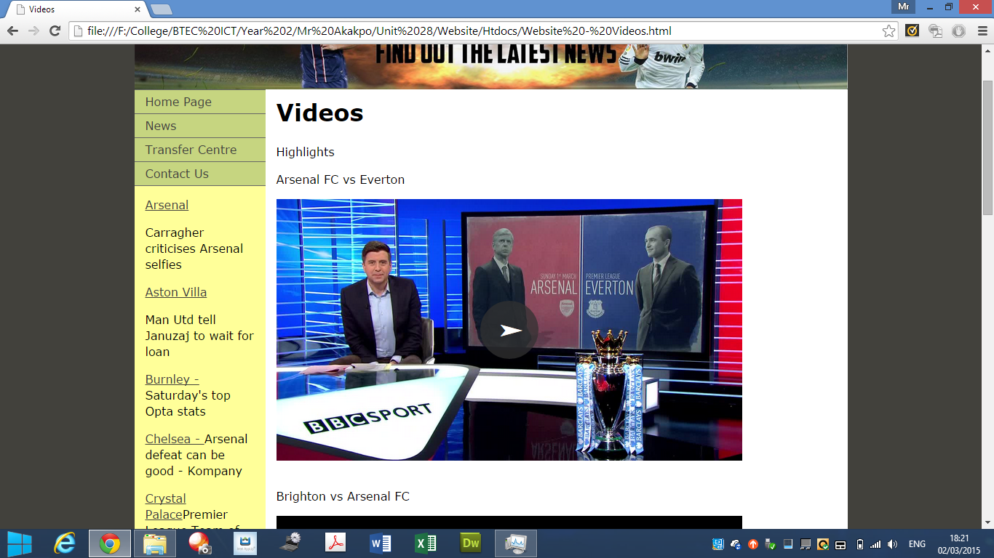**Videos**

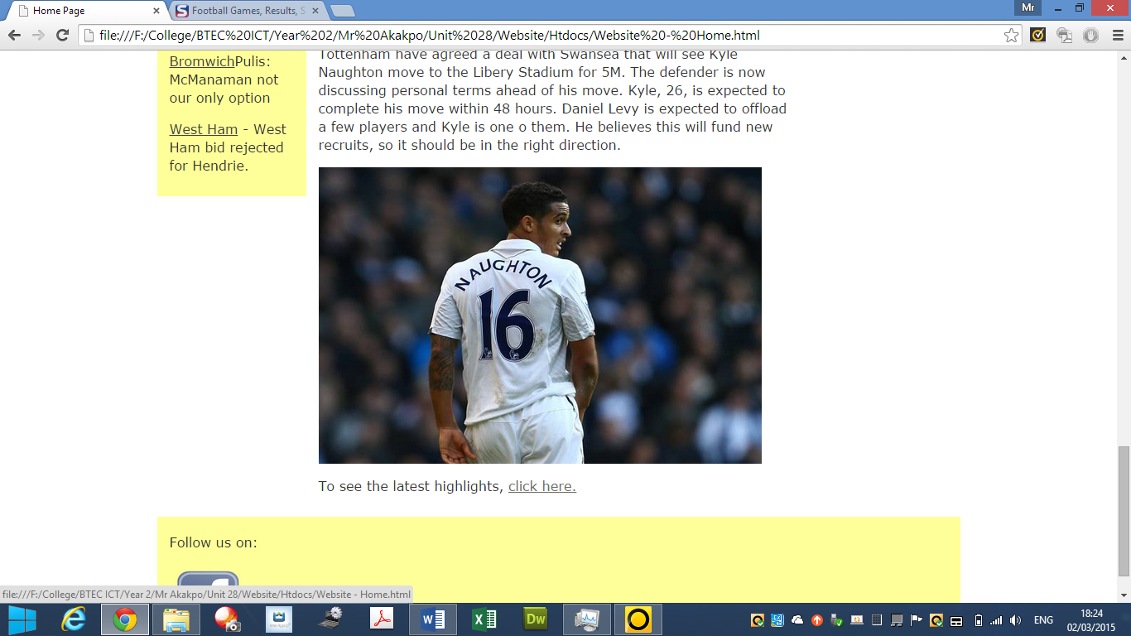The home page consists of general information about football. It has images and a link to refer to the user of videos. To refer to the videos, the user clicks on ‘click here’ to see the video🡪.

Videos are important to be inserted within any website. Eventually, the user would get bored reading the information. Videos are entertaining.

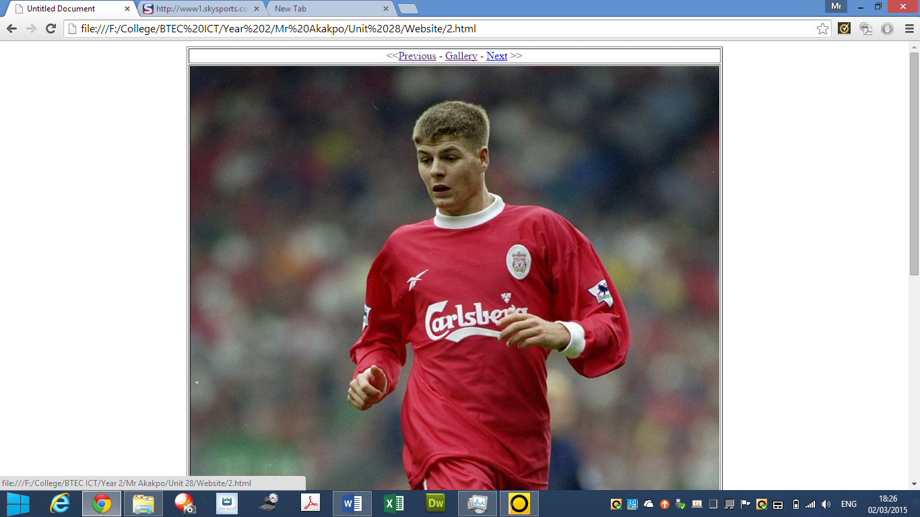**Photo Gallery**

A photo gallery has been inserted within my website to meet the requirements that were set. These images contain the Liverpool skipper Steven Gerrard. All you do is click on go next and previous to see Gerrard’s career in pictures. To view the galleria, you click on ‘click here’.

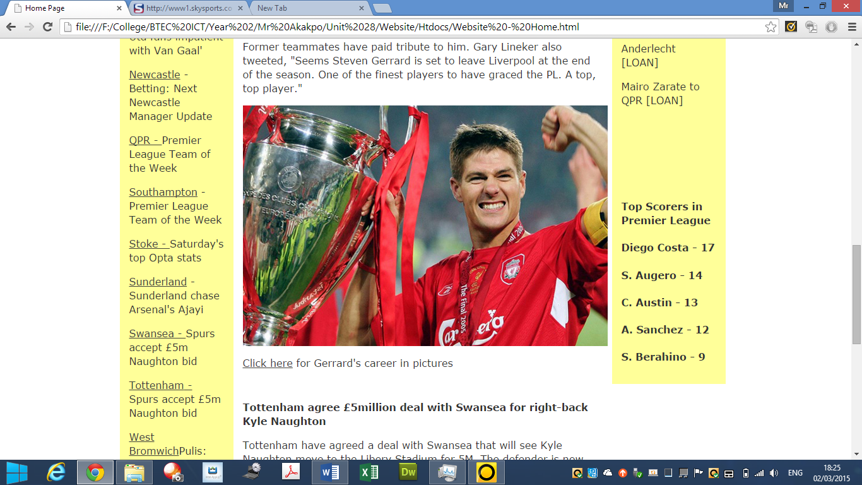

**Reference**

[**http://malachiafaulkner.blogspot.co.uk/2013/05/p5.html**](http://malachiafaulkner.blogspot.co.uk/2013/05/p5.html)